**Chapter Two: Can maths predict the future?**

1. **Introduction**

In the last chapter we looked at how we could construct a mathematical model. In this chapter we will ask whether we can use this mathematical model *to predict the future!* Admittedly this is one of the most important questions we could ever ask. Whole industries (including for example gambling, and insurance), not to mention many major religions, as well as soothsayers, mystics, astrologers, governments, and climate scientists, owe their very existence in part to attempts to answer this very question. So, I ask again, is it possible for us to predict the future? Hands up for your thoughts on this.

In one sense there is an easy to answer. For a human being it is very likely that for most practical purposes of importance to our lives, we can predict 0ne second into the future. Much of what we see around us on human time and length scales doesn’t change much, if at all, over a period of one second. A computer model of the weather, or of the climate, or of the complexities of a city, would have little difficultly predicting the behaviour over the next second with high accuracy. However, for a sub atomic particle one second is a very long time indeed over which a great deal can happen. Computer models of particles and molecules typically operate over very short time-scales and find it hard to predict for such a long time as a second (which is why computer simulations of chemical reactions are very computationally intensive and time consuming). If I was to ask again, can we predict what is going to happen in an hours time, again we could be pretty sure of the answer. I expect that those of you who are reading this book will still (I hope) be here, and that the world hasn’t ended. Almost certainly you will still be alive (although you may not still be reading this book) and, although we will have aged slightly, your bodies will function much the same as they did an hour ago. If we now extend this to a day we can still predict some things quite well. For example with over 70% probability the weather tomorrow will be the same as today. This is called the *persistence forecast* and any weather forecast has to be better than this to be deemed useful. It takes a surprising amount of careful computation to do better than this, and I will return to this in my next lecture. The trains will probably run to the same time-table and my house will still be there. However other things may have changed much more, for example the stock market can crash in a day and a violent storm can arrive. The further we go into the future the harder it is to say anything with certainly. For example reliable weather forecasts are usually impossible after a period of about ten days, and no one can predict what the economy will look like in a year. Almost no one at the end of 2019 could have predicted the huge changes to our lives that happened in 2020.

Indeed as the great Danish physicist Niels Bohr said

*It is hard to predict anything, especially about the future.*

Notably Niels Bohr was one of the fathers of quantum theory which has uncertainty at a sub-atomic level, built into its very fabric.

Central to our understanding of how well we can predict things, is explaining how the same things can change (and the associated level of risk associated with such changes). Often change is slow, as we have seen in the case of the weather. (In fact if you live in certain parts of the world then the weather can seem to be the same every day).

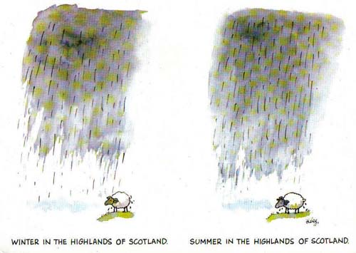

Similar slow change is seen in evolutionary systems in biology, or in geology. Sometimes change is expectedly fast, such as in a volcanic eruption, or a 200m hurdles race. Both are, in a sense, predictable events. What is much harder to predict are sudden changes (also called tipping points or *black swan events*) which arise when a seemingly stable (one might say boring) system changes suddenly and catastrophically. This might arise through the action of a significant external cause, such as the extinction of the dinosaurs, 65 Million years ago, by an asteroid or the sudden arrival of the COVID-19 virus in 2019. However it can also arise of its own accord when the accumulation of small causes suddenly leads to a very large and possibly irreversible change. Traditionally this is thought of as *the straw which broke the camel’s back.*

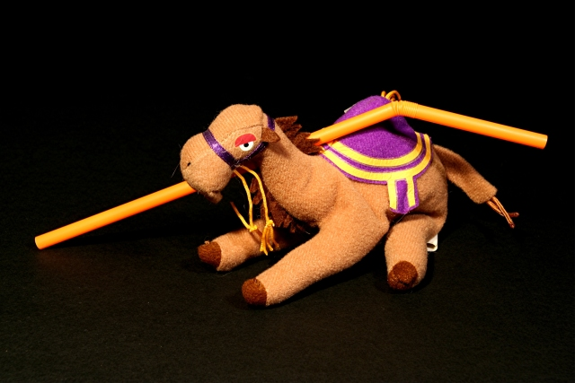

Examples of this sort of behaviour occur in nature such as an avalanche, in engineering such as a power cut (as we shall see in Chapter 4 on Energetic Mathematics), or in human history, such as the very rapid chain of events, which led to the start of the First World War. We are possibly seeing a similar type of behaviour with the current changes to our climate. Insurance companies would love to have good answers to the question of whether we can predict sudden change. However this seems to be philosophically the contradictory question of *Can we predict the Unpredictable?*

Well, in this Chapter, (and the next one on climate change) we are going to have to have a look at using mathematical models not just to predict the future, but also to see how predictable the future can be, how small changes now will affect things in the future, and whether we are likely to see things going on more or less as they are now, or instead will change suddenly. In doing this we will combine mathematical modelling with a touch of chaos.

1. **A brief history of telling the future.**

We saw in the last chapter that not only could a mathematical model (based on Newton’s laws) predict the motion of a pendulum, but that models based on the same laws could not only predict the motions of the planets, but could even predict the existence of new planets.

These great success stories gave the mathematicians and scientists after Newton great confidence in the ability of mathematics both to describe the world that they lived in, but also to predict how it would behave in the future.

In many respects they were right to do this. Indeed the design of modern technology such as the mobile phone or and aeroplane is based on the power of mathematics (and computers based on that mathematics) to predict exactly how the phone or aeroplane will work, well before it is actually made.

In fact a mobile phone works because of Maxwell’s laws for electromagnetism. These were a set of differential equations linking electrical, E, and magnetic fields, B, that were written down by James Clerk Maxwell as a mathematical model that summarised the empirical observations of Michael Faraday in the experiments that he did at the Royal Institution in London (at which august establishment I happen to be the current Professor of Mathematics). Maxwell’s equation expressed in the current notation of vector calculus are given below. Technically speaking they are a set of *coupled linear partial differential equations.* Remember the word *linear* we will come back to that big time later.

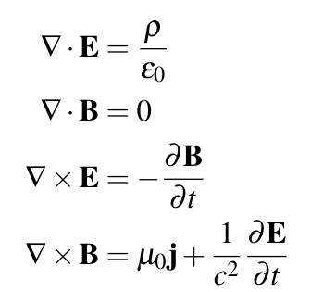

Ok, they look pretty scary, but that didn’t put Maxwell off. By using mathematical methods which had just been developed to find the solution to partial differential equations, Maxwell *was able to solve them exactly*. What he found was remarkable. The solutions were *waves* of electricity coupled to waves of magnetism. When he calculated the speed of the waves the result was simply astonishing. The waves *had the same speed as the (also recently calculated) speed of light.*I wonder what Maxwell thought when he discovered this, for he had done nothing less than to find the formula for light, simultaneously uniting the fields of electricity, magnetism and optics. I know what I would have done! At this point Maxell had used his mathematical model to *describe* the universe. But now he pushed it further to *predict something new.* What Maxwell realised that his equations had many solutions which corresponded to different waves of different frequency and wavelength, but all moving at the speed of light. Some of these were light waves (of different colours), some were of higher frequency (such as Ultra Violet waves and X-rays) and some had a slightly lower frequency (such as the infra red rays which had also recently been discovered). But some, of lower frequency were *completely new* and a novel prediction of the mathematical model. We now call these radio waves. Not only did Maxwell’s equations predict their existence (and speed) it also allowed the mathematicians of the day to predict many of their properties. They were only found experimentally, by Hertz, some years later.

Pause to think what the world would be like without the discovery of radio waves. We would have no radio, no TV, no Radar, no WiFi, no Internet, no mobile phones, and no micro-wave cookers!

**Simply put the modern world would not exist!!!**

All this as a result of the predictions of a mathematical model.

What else could be done? Indeed it was felt in the 19th century that as the universe was made up of atoms, and the atoms obeyed Newton’s laws, then their motion could be predicted with high accuracy and for a long time and hence mathematical models could be used to predict just about anything. This led the celebrated French mathematician Pierre Simon Laplace (who made many profound contributions to both pure and applied mathematics) in 1814 to make the following bold statement:

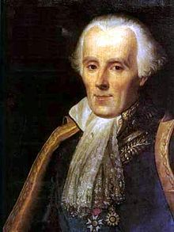

*We may regard the present state of the universe as the effect of its past and the cause of its future. An intellect which at a certain moment would know all forces that set nature in motion, and all positions of all items of which nature is composed, if this intellect were also vast enough to submit these data to analysis, it would embrace in a single formula the movements of the greatest bodies of the universe and those of the tiniest atom; for such an intellect nothing would be uncertain and the future just like the past would be present before its eyes.*

This intellect is often called ‘Laplace’s Demon’ [1] and it is the ultimate mathematical modeller. It seems to be able to know the future exactly, and there seems also to be no chance, unpredictability or free will. The possible existence of such a demon is in itself a very frightening prediction.

But is it really true? Indeed, realistically how good are mathematical models at predicting the future, and are mathematical modellers really demons?

1. **Where does it all go wrong? Enter chaos theory.**
   1. **Unpredictability in nature**

If we think about our reality for just a moment, It is hard to equate Laplace’s bold prediction and the existence of his demon with the world that we observe around us. Perhaps for the human condition, this is no bad thing Despite the work of Newton and Maxwell much of the world really does appear to be unpredictable, especially where human beings are involved.

Examples occur everywhere from the behaviour of the FTSE index (see below), to that of my dog. Indeed human behaviour is inherently unpredictable, and we are able (in defiance of Laplace’s demon) to be able to exercise free will.

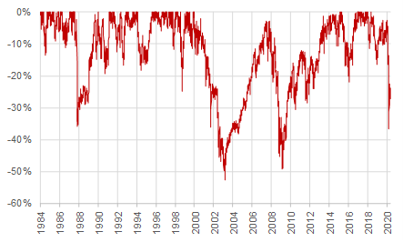

Unpredictably also occurs in the physical world even when we are pretty sure of the underlying physical laws. Despite the existence of the Navier-Stokes equations which give an excellent model of the way that the atmosphere moves around and are excellent for short term predictability of this (hence the success of the daily weather forecast), they are hopeless in telling us what the weather will be doing in ten days. Similarly certain climatic phenomena are also very difficult to predict. A good example of this is the El Nino Southern Oscillation (ENSO) phenomenon in which we see a rapid warming of the Southern Atlantic Ocean roughly once every four years. A plot of the Southern Ocean temperature is given below. Whilst there is a rough periodicity of four years to the ENSO, the plot below of the sea surface temperature (which it is believed is mainly caused by large scale ocean circulation patterns) is any thing but regular. We shall return to the ability (or not) of mathematics to predict the climate in the next chapter.

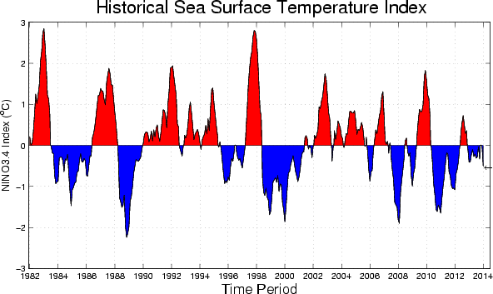

Seemingly erratic behaviour can also be observed in brain wave patterns as measured by an EEG. These are shown below.

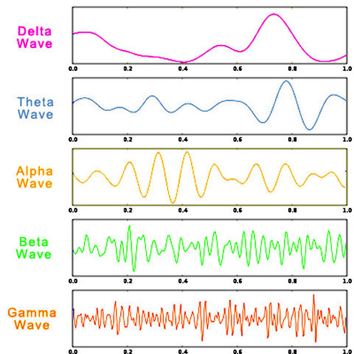

So, unpredictability really does seem to be all around us, from the motion of molecules to that of the atmosphere, and from the behaviour of a dog to the waves in the brain.

However, this seems in contradiction to the ordered universe predicted by Laplace. With the success of Newton’s laws in predicting the future in some cases we are thus led to ask the following question:

*Does the unpredictability we see in many cases in nature, arise because nature really is complex and unexplainable*

Or in contrast

*Can seemingly unpredictable behaviour arise from systems governed by Newton’s (and other physical) laws?*

* 1. **Chaos and the double pendulum**

Before we rush into the complexities of the climate (in the next chapter) we will try to answer this question by looking at a relatively simple system, which, without question, is governed by Newton’s laws of motion. This is the *double pendulum* which is an extension of the simple pendulum studied by Galileo which we looked at in Chapter One, and which opened our eyes to the power of mathematical modelling.

A double pendulum is two pendulums coupled together, in much the same way that our leg has two bones coupled by the knee joint. Each of the two pendulums is free to move independently under the action of gravity, but they are joined together by the pivot in the middle.

A schematic of the double pendulum is shown below. In this we will think of the double pendulum as made up of two freely swinging bars of length l1 and l2. The top bar swings from a (frictionless) pivot at the top, and the second from a (frictionless) pivot on the first pendulum.

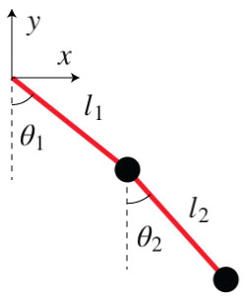

What could be simpler. This system has only two moving parts (the top and bottom parts of the pendulum), each of which has a position and an angular velocity. It has thus only ***four* degrees of freedom.**

This is far fewer than the weather, which has billions of degrees of freedom. We might be tempted to think that the double pendulum will therefore have nice simple behaviour.

**We would be wrong!!!**

Just like the weather the double pendulum can have remarkable complex behaviour. In fact it has three distinct types of motion, two of which are simple and predictable and the third of which is complex and anything but predictable.

If the top and bottom parts of the pendulum are pulled together a *small* amount to one side, then they will continue to swing to and from *in phase* (meaning that they move in the same direction) in a regular manner. See the left part of the figure below. This is just like the periodic motion of the simple pendulum and is very predictable.

In contrast, if the two pieces are pulled in *small* opposite directions and released then they will continue to move periodically to and fro but in opposite directions. Thisis what is called *out of phase* motion. See the right part of the figure below. This periodic motion will also continue indefinitely in a very predictable way.



Finally, but most interestingly, we will give the pendulum a large swing and see what happens next. What we see is truly remarkable. Instead of periodic motion, the double pendulum will continue to move **in a most erratic and seemingly random manner**.

(You can find many examples of this on the internet. Just type ‘double pendulum’ into Google and watch the movies. See if you can predict what will happen next.)

An illustration of this is given below. In this picture a light is attached to the lowest part of the double pendulum and a picture of the motion of this recorded over time. Not only is the motion extremely complex and hard to predict, if the pendulum is set off again as close as possible to the same position as before, then after a very short time it will move in a completely different way. Such a pendulum seems to defy the predictability we observed earlier and would be a poor timekeeper!

We call this motion *chaotic.*

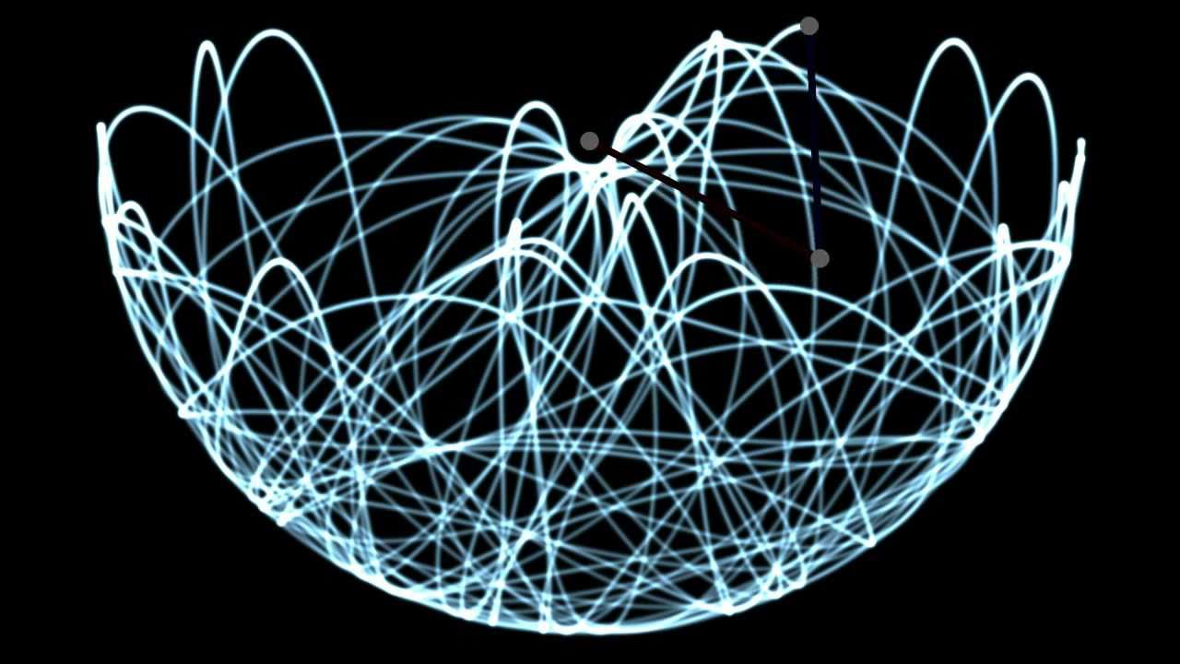

Chaotic motion has two main features:

* It is extremely complex. It does not seem to obey any predictable pattern.
* It displays ‘sensitivity to initial conditions’. If you start a chaotic system off in two slightly different ways then the two types of motion rapidly become completely different.

If this resembles the way the weather behaves, then that is no coiincidence.

So, what is going on here? It might be possible to argue that chaotic motion appears to be random because the double pendulum is simply responding to random air currents which are blowing it around in lots of different directions. However this is not the case. The air currents certainly have an effect, but it is not them that make the motion of the double pendulum chaotic.

To show this we will create a mathematical model of the double pendulum’s.

We will follow the same procedure that worked so well for the simple pendulum by writing down the equations of motion of the double pendulum and then solving them.

We start by thinking about what is going on. In its usual form, the double pendulum (a little unlike the case of the chandelier we looked at in Chapter One) comprises two rigid metal bars of respective masses m1 and m2, and lengths l1 and l2. The top bar is pivoted on a fixed, frictionless pivot, and makes an angle θ1 to the vertical. The lower bar is pivoted at the lowest point of the upper bar (again frictionlessly) and makes an angle θ2 to the vertical. The whole system is then acted upon by gravity. If the masses m1 and m2 are reasonably large then, to a good approximation, we can ignore the resistance of the air. We will also ignore any vibrations in the top pivot (in practice we have to clamp the double pendulum pretty hard to make sure that this doesn’t

Now we write down the equations. I will make a confession here. This is not easy. To do this you need to use quite advanced mathematical techniques which involve calculating the Lagrangian of the double pendulum (which is the difference between it its kinetic and potential energy) and then applying Lagrange’s equations of motion. (Lagrange was another famous French mathematician who’s name began with L. There are at least two others). Usually these techniques would only be taught in the advanced mechanics course of an undergraduate degree. However, they are very powerful, an essential to master if you want a career in robotics or satellite design or indeed in any field where you want to work out the advanced motion of a coupled system. This includes computer animation, and the movie industry. (Advert: Holywood employs lots of mathematicians for exactly this reason).

To cut a long story short the motion of the double pendulum can be *completely described* by the following pair of coupled nonlinear second order ordinary differential equations which give us our mathematical model of its behaviour:

latex-image-1.pdf**latex-image-1.pdf**

*This differential equation is another example of a problem that we cannot solve exactly by hand*

When we encountered this issue with the simple pendulum we decided to simplify the system by only looking at small swings.

If the angles are *small* then this system can be approximated by a set of linear ordinary differential equations which look like:



These differential equation *can* be solved exactly. The solutions give exactly the in phase and out of phase behaviour described above.

However, we have just committed a modelling crime. By making the ‘small angle’ simplification we have missed out on the really interesting behaviour of the double pendulum. (As we remarked in Chapter One, we have to be constantly on our guard to avoid making the mistake in any mathematical model of over simplifying it to the extent that we throw away the real essence of the problem that we are trying to solve).

If we were doing our mathematical modelling 100 years ago then that would be as far as we can get. But now with the availability not only of fast computers, but also great algorithms to solve differential equations, then we can find a very good numerical approximation to the solution of our mathematical model, and simulate its motion on the computer. If you have access to the computer language Python which has inbuilt tools to solve differential equations then this is very easy to do. (An example of some Python code to do this is given at the end of this Chapter.)

Here is example of a computer simulation of the double pendulum in which m1 = 1 kg, m2 = ½ kg, l1 = l2 = 30 cm and g = 9.81 metres per second per second. In this simulation we plot the location of the bottom of the lower part of the pendulum, and start the pendulum off with a good push.

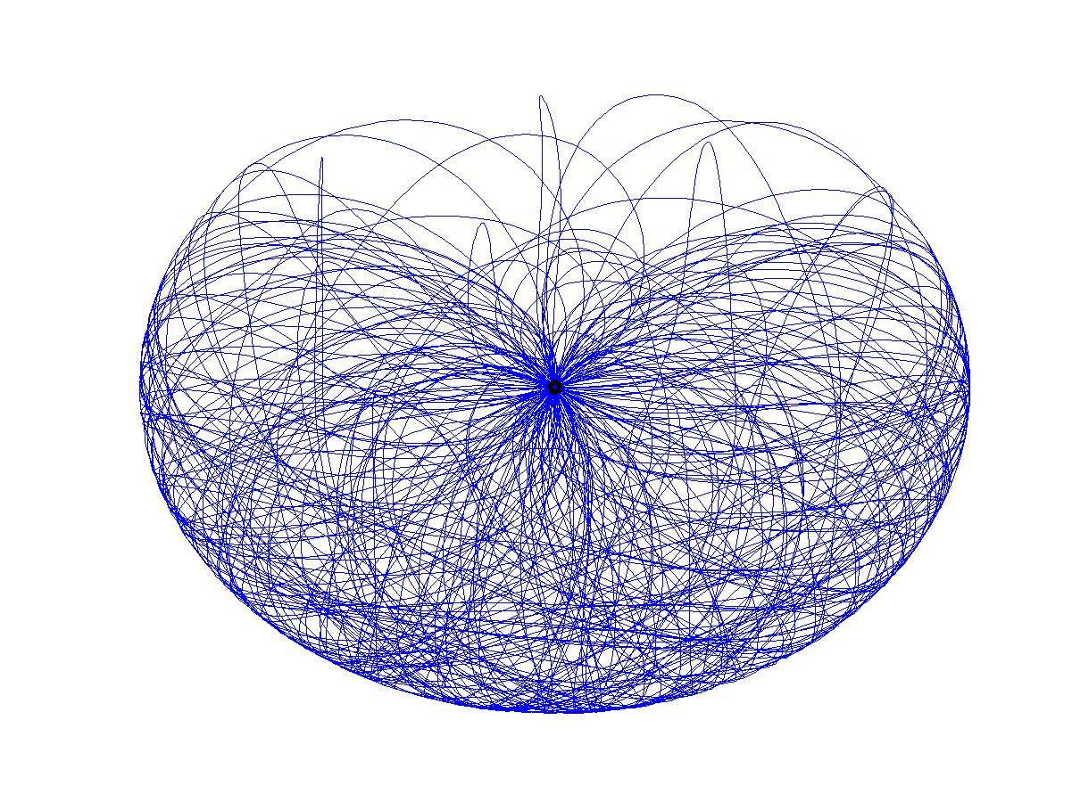

Remarkably, if we compare this with the figure above of the real pendulum we see that the computer simulation gives qualitatively exactly the same behaviour as the physical system. In particular this figure shows that the lower part of the pendulum moves almost randomly, just as in the real situation. Reassuringly the same computer simulation gives the in phase and out of phase periodic behaviour when we start the double pendulum off with a small swing. In short the model works! And we can use it to make predictions, such as the average position of the pendulum (which we will see in the next chapter is relevant to climate simulations). However, what we cannot do is to make predictions of what the pendulum will be doing at a point in the future. To show you why not we will take two very similar pendulums, which start from rest. In the first we start with θ1 = 2 and θ2 = 1 (both measured in Radians). In the second we start with θ1 = 2.001 and θ2 = 1, and we run the system for 60s. The two pendulums have started very close to each other (far closer than it would easy to arrange in an experiment) However, at the end of this time the first pendulum has θ1 = -1.6466, and θ2 = 0.4249 , whilst for the other pendulum we have the very different values of θ1 = -1.1372 and θ2 = -0.8078

What this modelling exercise has demonstrated is something very profound. The mathematical equations that we have simulated are derived directly from Newton’s laws of motion, and their solution appears to be erratic and almost completely random and unpredictable . In other words

**Chaotic behaviour really does exist as a solution of Newton’s equations.**

Or in other words, we can expect to see what appears to be random and unpredictable behaviour from systems governed by

The implications on our ability to predict the future using mathematical models is profound indeed.

There are other types of pendulums, which display similar behaviour to the double pendulum. A beautiful example is the *chaotic water pendulum* which can be found in St Mary Redcliffe Church in Bristol, UK and was designed by Sir Brian Pippard. Water running down the horizontal arm of the pendulum combined with the action of gravity causes the pendulum to swing in a chaotic manner. This combination of science and mystery makes this pendulum a very suitable object for contemplation in a church

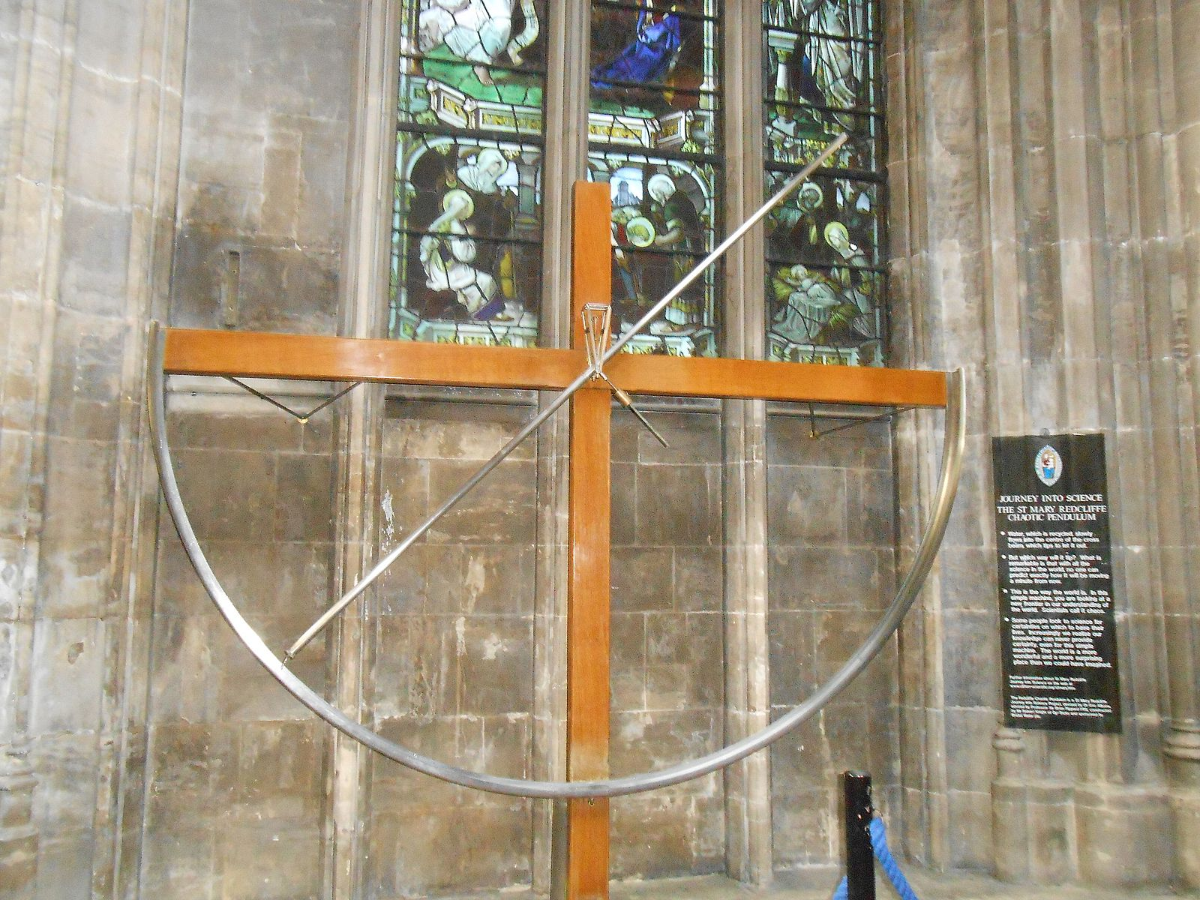

Motivated by this, from now on I will extend the earlier definition of chaotic behaviour to the following:

**Chaotic motion is complex, irregular and otherwise unpredictable behaviour with sensitivity to initial conditions, which arises from a ‘system which can be exactly described by ‘simple’ mathematical laws.**

In the popular press the sensitivity of chaotic systems to their initial conditions is often called the *Butterfly Effect*. This term was coined by E. Lorenz in the 1960’s [2]. Lorenz was one of the pioneers of ‘chaos theory’ and he remarked that if the weather was chaotic then the flap of a butterfly’s wings in Brazil could cause a hurricane in Europe. (We now know that whilst the weather is almost certainly chaotic in the sense described above, the perturbations have to be much larger than a butterfly to make any significant difference. In essence the butterfly would have to have wings about 1 km across to cause any real effect.) The idea of the butterfly effect has certainly caught the public imagination. The idea of even tiny changes leading to huge effects in the future seems to resonate with some of our perceptions of how the universe might work. Many books and even a film [3] have been written about it, and a remarkably prescient early story about it (also involving butterflies) was written in [4] before Lorenz had even coined the phrase.

In a sense the butterfly effect allows us to combat Laplace’s demon. The demon in question would have to know the positions of all of the particles to infinite precision to be able to make any predictions at all. Furthermore, the inherent microscopic randomness ever present due to the action of quantum effects will be immediately amplified by the butterfly effect to make long term predictability of a chaotic system quite impossible.

Chaotic behaviour in the manner described above exist in many, many, other physical systems. One of my favourite examples is *chaotic billiards*. Imagine a billiard ball bouncing around a table, so that when it comes into contact with the edge of the table it reflects from in it the same way that light would reflect from a mirror. The resulting pattern of bounces from a stadium shaped billiard table is given below:

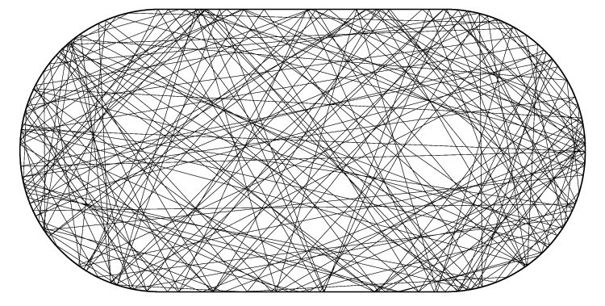

The observed pattern of motion is highly complex, and yet, like the double pendulum, it arises from very simple laws of motion. This problem has very practical application in optics (to find light illumination patterns), acoustics and also in high frequency WiFi. In the latter example the lines in the above picture correspond to the rays of electromagnetic radiation which bounce around a room after leaving a WiFi transmitter. The very complex picture above means that it is remarkably hard to predict the strength of WiFi coverage inside a domestic room.

Truly chaotic behaviour is everywhere, from the weather to the motion of the asteroids, and from the double pendulum to the behaviour of electrical circuits. Indeed it was the mathematical study of the equations of a particular type of electrical circuit (the van der Pol oscillator) by Dame Mary Cartwright during WW2 which led to the one of the original descriptions of the butterfly effect. (The engineers at the time thought that the erratic behaviour that they were observing in their oscillators was due to faulty equipment. Cartwright showed that this wasn’t the case, and led the engineers to better ways of designing their oscillators to eliminate the chaotic ‘noise’.)

It is interesting to contrast this erratic behaviour of an electrical system, with the enormous predictability of Maxwell’s equations. This leads us to ask three questions.

**Firstly**: what is it about some problems which means that they are likely to have chaotic behaviour.

**Secondly:** can we predict *anything* about the behaviour of a chaotic system.

And

**Thirdly:** What is the ‘use’ of chaos?

The answer to question one lies in the issue of linearity which I said was the key to the predictability of Maxwell’s equations. The answer to second is lots! But we have to be careful about what we try to predict. For the answer to the third, read the rest of this book, although I will give a short summary at the end of this chapter

Let’s look a bit further to find the answers.

1. **Chaos theory** 
   1. **Overview, and the Lorenz equations.**

Although what we would now call chaotic behaviour had been observed earlier by Cartwright, the modern terms of *chaos* and of *chaos theory* arose came from a paper 1963 by the meteorologist Ed. Lorenz, which was published in 1963 [2]. It is no coincidence that this paper was written shortly after the availability of fast electronic computers, the existence of which made the study of chaos in detail possible. Lorenz was trying to study the motion of the atmosphere, in particular by looking at the way that hot air rises during convection (which is known to be a play a major contribution to the weather).

Lorenz followed the now, hopefully familiar, process of mathematical modelling described in Chapter One. In particular he wrote down a system of equations for convection which were based on the Navier Stokes equations for atmospheric motion which we also met in Chapter One. These were much too hard to solve, either analytically, or by the computers which were around in 1963. So Lorenz had to simplify them to make progress. He did this by assuming that there were *three* different modes (likely shapes) of the behaviour of convection, which had amplitudes x(t),y(t) and z(t), and which evolved in time. He then projected the convection equations onto these three modes to get equations for x,y and z.

(Unlike the equations for the double pendulum, the Lorenz system really is a big approximation to reality as in reality there are very many more than three modes which make up convection.)

By doing the projection in [2] Lorenz came up with what are now known as the Lorenz Equations. These have the form



In case these look familiar, they have a similar form to the SIR equations which we used to study the spread of an epidemic in Chapter One. Both are systems of three ordinary differential equations, and both involve products of terms in their right-hand sides. However there the similarity ends. Whilst we can exactly predict the behaviour of the solutions of the SIR equations, those of the Lorenz equations are chaotic and unpredictable.

Before the 1960’s it would have been impossible to solve this system accurately. However, the 1960s saw the first use of fast digital computers, which could solve differential equations using (for example) the *Runge-Kutta* algorithm. Lorenz applied this to the equations above and was remarkably surprised. Rather than the periodic behaviour he was expecting the solutions of the Lorenz equations were very complex. Looking for a way to describe them Lorenz coined the word *chaos* for the motion, and the *butterfly effect* for its sensitive dependence. Significantly he felt that what he was seeing reproduced the erratic and turbulent behaviour observed in the atmosphere itself. In this he was wrong, whilst the motion of the atmosphere is chaotic in a sense, it is not described in any meaningful way by the Lorenz equations.

A plot of the evolution of x(t) using a fixed set of the parameters (of meteorological significance) is given below. This plot shows the chaotic behaviour with a complex trajectory as time increases. In this plot two slightly different initial conditions for x(0) are taken. Whilst the two trajectories are close up to a time t = 24, they differ significantly after this time.

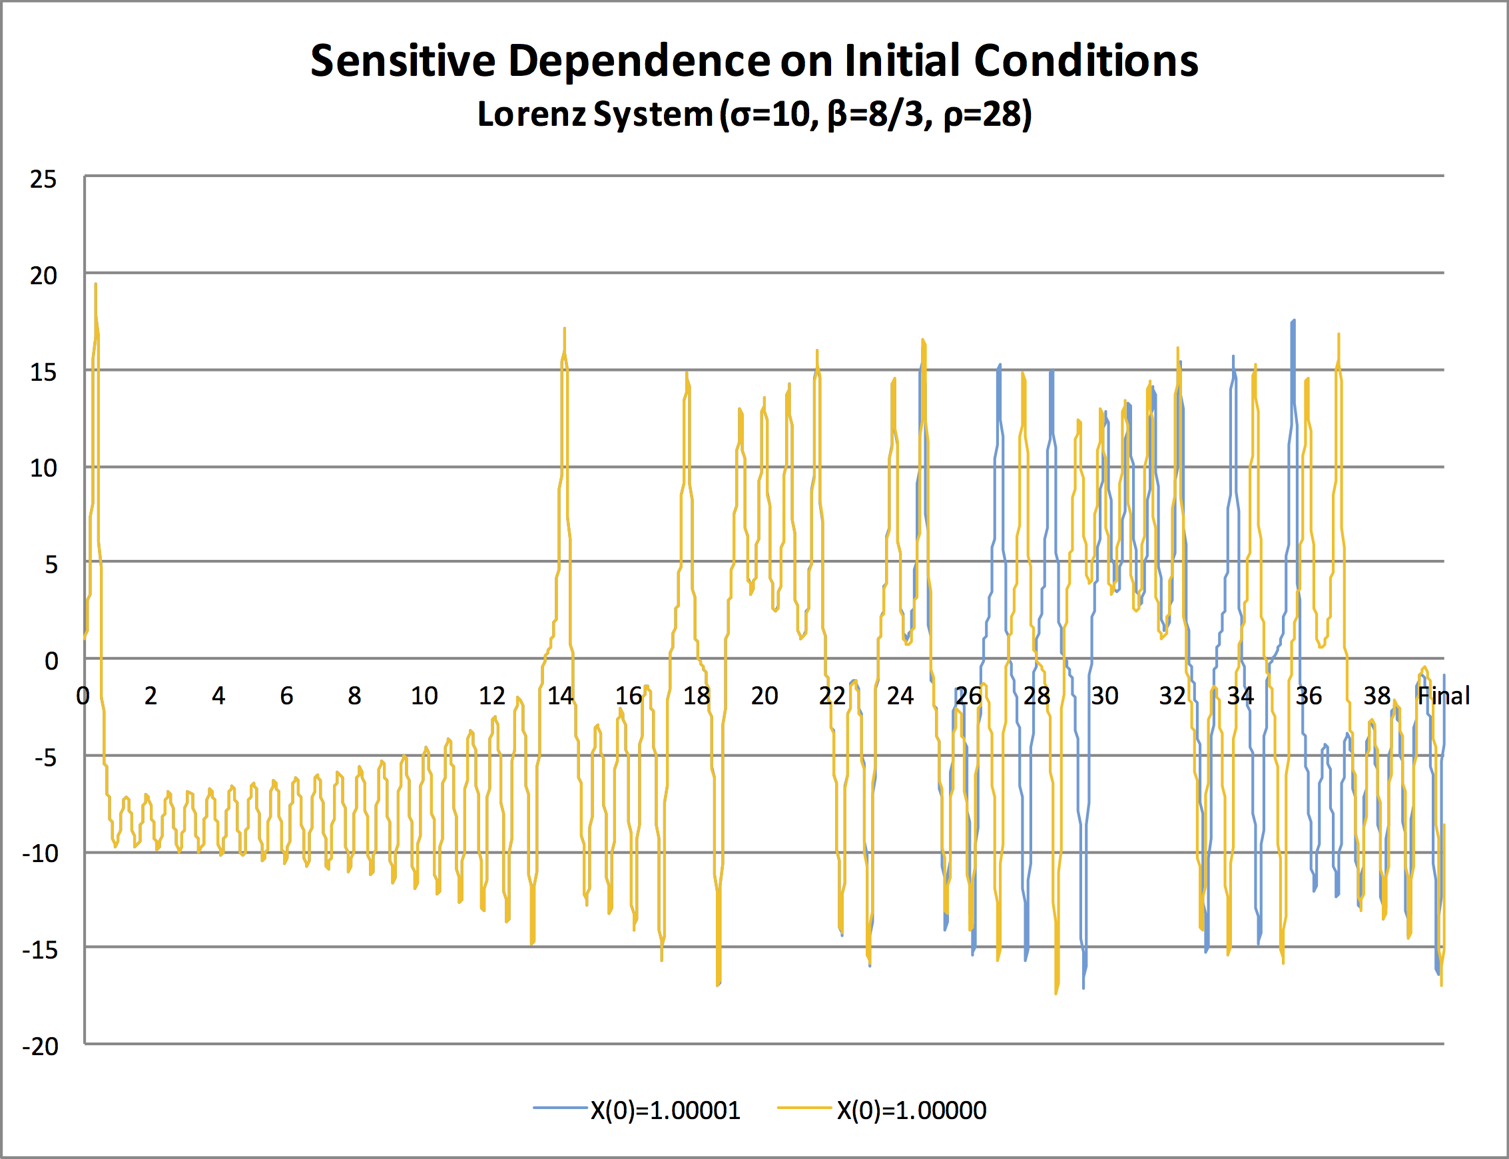

A plot of x(t) and y(t) together is even more revealing. In this case the points (x,y) move around an (appropriately) butterfly shaped set. This set is called a *strange attractor* because it attracts all trajectories but is neither periodic or a fixed point.

Although the points more around the attractor in a chaotic manner, the shape of the attractor is itself well defined. Here we see the organisation which is at the heart of chaotic systems. Although their individual motions can’t be predicted, the shape of the set that they move on can. This allows a lot of predictions to be made about the average properties of a trajectory. This important feature of any chaotic system becomes very important in the next chapter when we look at climate.

The strange attractor itself has a fine structure and beautiful and is an example of a fractal set. This means that if you magnify any part of the curve then it continues to have complex structures at any scale.

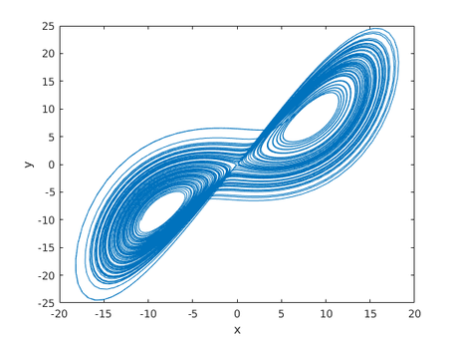

The discovery of chaos in the 1960s caused a sensation and led to an explosion both of research and also of articles in the popular press and a huge amount of hype, only some of which was justified. The celebrated book by James Gleick [5] made the discovery almost look like a murder mystery! More scientific, but equally readable accounts of chaos theory and its implications can be found in Stewart [6] or Strogatz [7].

As we have seen much of the real credit for the mathematical analysis of chaos should be given to Mary Cartwright. However, in many ways the existence chaotic dynamics had been discovered rather earlier, and the credit for its discovery is largely due to the great French mathematician Henri Poincare.

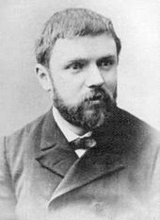

Poincare was at the time investigating the stability of the solar system. It was well known (as we have already seen) that if a single planet moves around the Sun, then its motion is periodic and can be predicted exactly using Newton’s laws. However, Poincare was able to show that a system of three bodies of similar mass and moving under gravitational attraction only would move in an irregular orbit. We now recognise this as just another example of chaotic motion. I will talk more about this in the final chapter of this book when Maths Goes Into Space.

* 1. **The logistic map and its implications**

It is hard to see how the chaotic behaviour in the Lorenz system, or the double pendulum arises, so we will now look at a simpler system, which has similar behaviour and can be studied in much more detail. This is the celebrated *Logistic Map*. Let’s suppose that we want to predict the population of (say) a town from one year to next. This is a subject of great interest to a town planner who has to work out (for example) how many schools to build to meet a need in five or ten years time. To make this precise we will let x(n) be the population of the town in the year n, with n=0 set to be the current year at which point we know the town’s population x(0).

A simple mathematical model of population growth was proposed in 1798 by Malthus in his essay *On the principles of population*. Malthus postulated that in any one year a fixed proportion of the population would be born, and an equally fixed proportion would die. This meant that the population in year n+1 would be proportional to the population in the year n, or in mathematical form



Here a is the constant of proportionality. This is an example of a *discrete dynamical system* in which we have a rule to advance the system from one generation to the next. In this case Malthus’ model has the simple and predictable solution given by:



If a < 1 then the population decreases, if a = 1 it stays the same, and if a > 1 it grows without bound, so called Malthusian, or **exponential**, growth. In Chapter one we saw exactly the same type of growth in the early stages of an epidemic (where R0 was used instead of a to describe the growth rate).

Malthus himself recognised that such behaviour was unrealistic, and that the population would eventually run out of resources and then start to decline. (Just as in an epidemic you finally run out of people that can be infected.) One way to do model is to introduce an upper limit M to the population to account for the effect of limited resources, and then to modify the Malthusian model to give



If we scale x(n) by dividing it by M, so that the maximum population is 1, and set r = a M to be the *scaled growth rate* we arrive at following famous model for population growth.



We call this a model for population growth a *map* as it describes the map from x(n) to x(n+1). The above map is so important that it is called the *Logistic Map*. Given a value of x(n) we apply the map above to it to give x(n+1). If we apply it to x(n+1) then we get x(n+2) etc. The Logistic Map is nonlinear and this is the reason why it generates such interesting behaviour.. Unlike the double pendulum or the Lorenz equations, this system can be studied very easily is you have access to a programmable pocket calculator or to ExCel. I recommend that you take x(0) = ½ , program the above function in, and simply iterate forward. Experiment by seeing what happens for a variety of values of the growth rate r, taking r between 0 and 4.

*The result of your experiments will be to find that the type of behaviour that you get depends critically on the value of r.*

The plot of the iterates for **r = 2.5** is given below. From a random initial start the system evolves to a fixed final state, or a *fixed point*, x. This is the solution of the equation

x = 2.5 x (1 – x) so that x = 0.6.

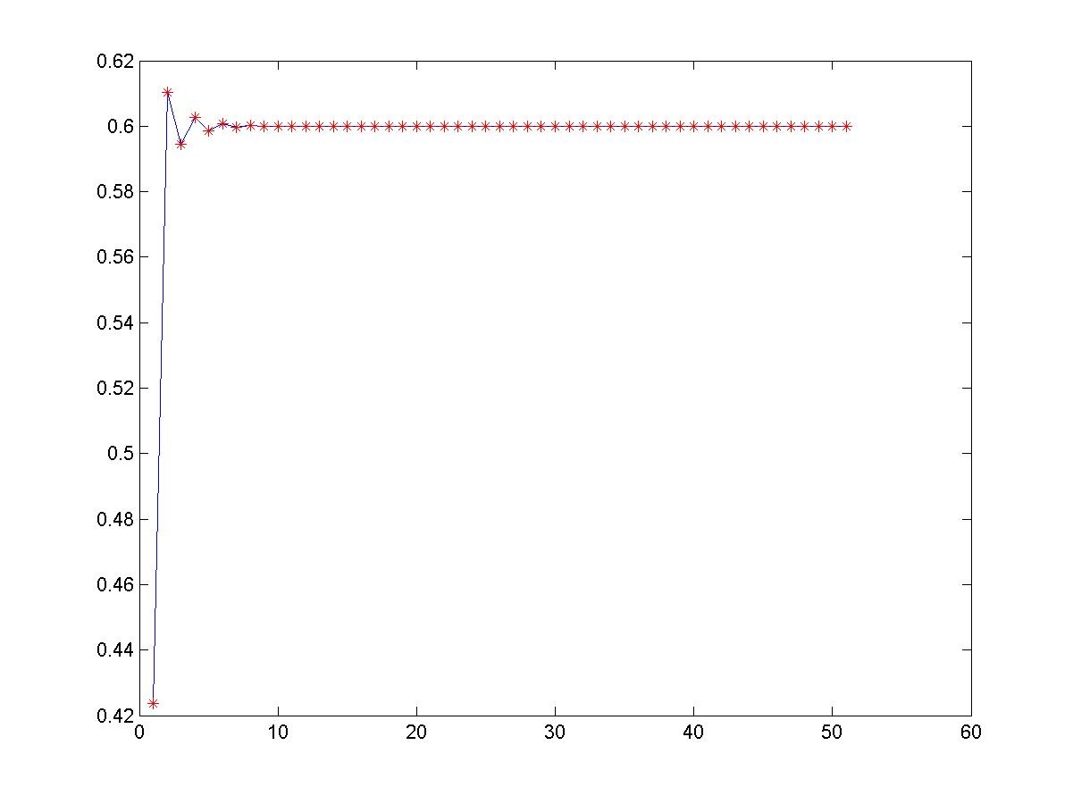

Such a final state is very predictable, and would be a town planners dream. Such predictable behaviour it exists for 1 < r < 3.

When r = 3 something remarkable happens. The fixed point becomes unstable and is replaced by a *two-cycle* in which the population varies between two different values. (This is rather like a boom-bust phenomenon in economics and is reminiscent of the out of phase response of the double pendulum). A picture of the two-cycle for **r = 3.2** is given below.

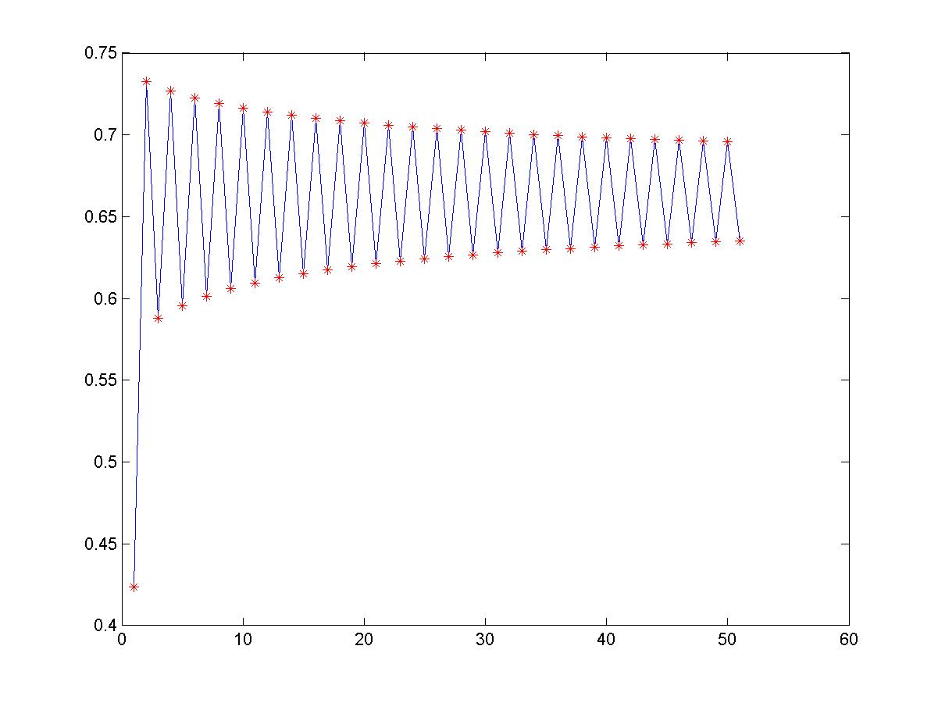

If we increase r further to **r = 3.55**, this picture changes again, and the two-cycle is replaced by a 4-cycle, in which x varies between four values as can be seen below

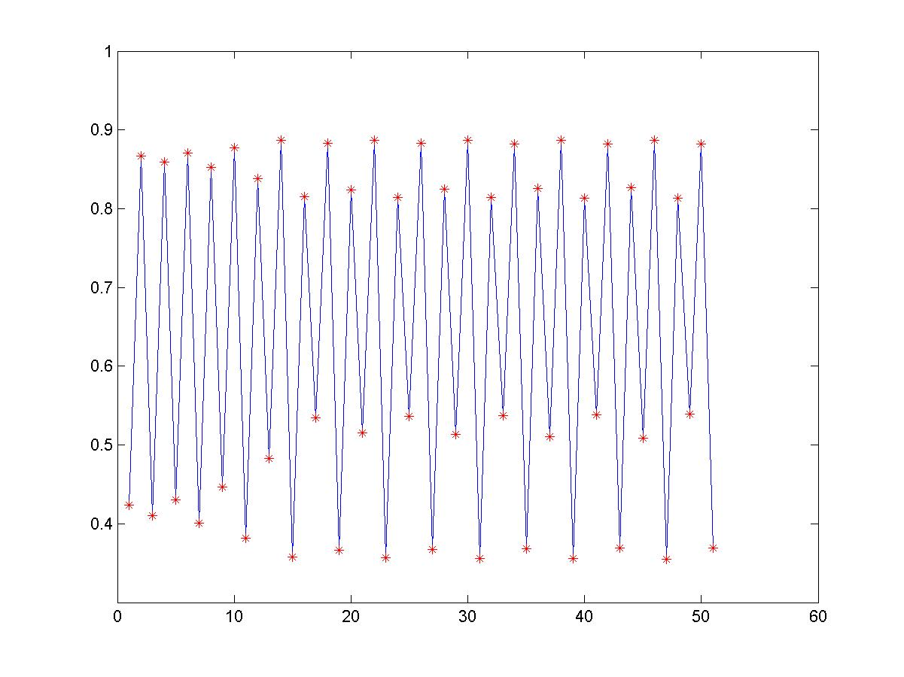



Increasing r leads to ever more complex behaviour, and for r > 3.56995 most values of r give chaotic behaviour. An example of this when is given below

It is worth reminding ourselves that this complex picture is obtained from the iterations of a very simple quadratic map.

We can study the case of r = 4 in some detail. Suppose that we set



Then some simple trigonometry shows us that





We can deduce from this that and hence that



Here we can see why we get chaos. Let’s suppose that we take to values of x(0) given by y and z which differ by one part in a million or 1/1000 000. The corresponding values of θ(0) will differ by a similar amount. However, every time we apply the map the difference in the two values of θ will double. If we iterate the map 20 times then this difference gets multiplied by 2 raised to the power of 20, which is close to a million. Therefore the difference in the two values of θ(20) for the starts at y and z will be one. The corresponding values of x(20) will be very different as a result. This has shown the extreme sensitivity to initial conditions that the Logistic Map has when r = 4. Another way of saying this is that small changes in x are approximately doubled at each iteration, but the cosine function stops these from becoming unbounded. This leads to random looking behaviour.

A complete picture of the behaviour of the logistic map for 2.4 < r < 4 is given by the *‘bifurcation diagram’* below, which plots the values of the final state of x(n) as a function of r. In this figure we can clearly see the single fixed point for r < 3, the period doubling to a two-cycle at r – 3, and the chaotic behaviour for r > 3.56995 including r = 4. There is also a stable 3-cycle around the value of r = 3.828. Much mathematical effort has been put into understanding this diagram in detail!

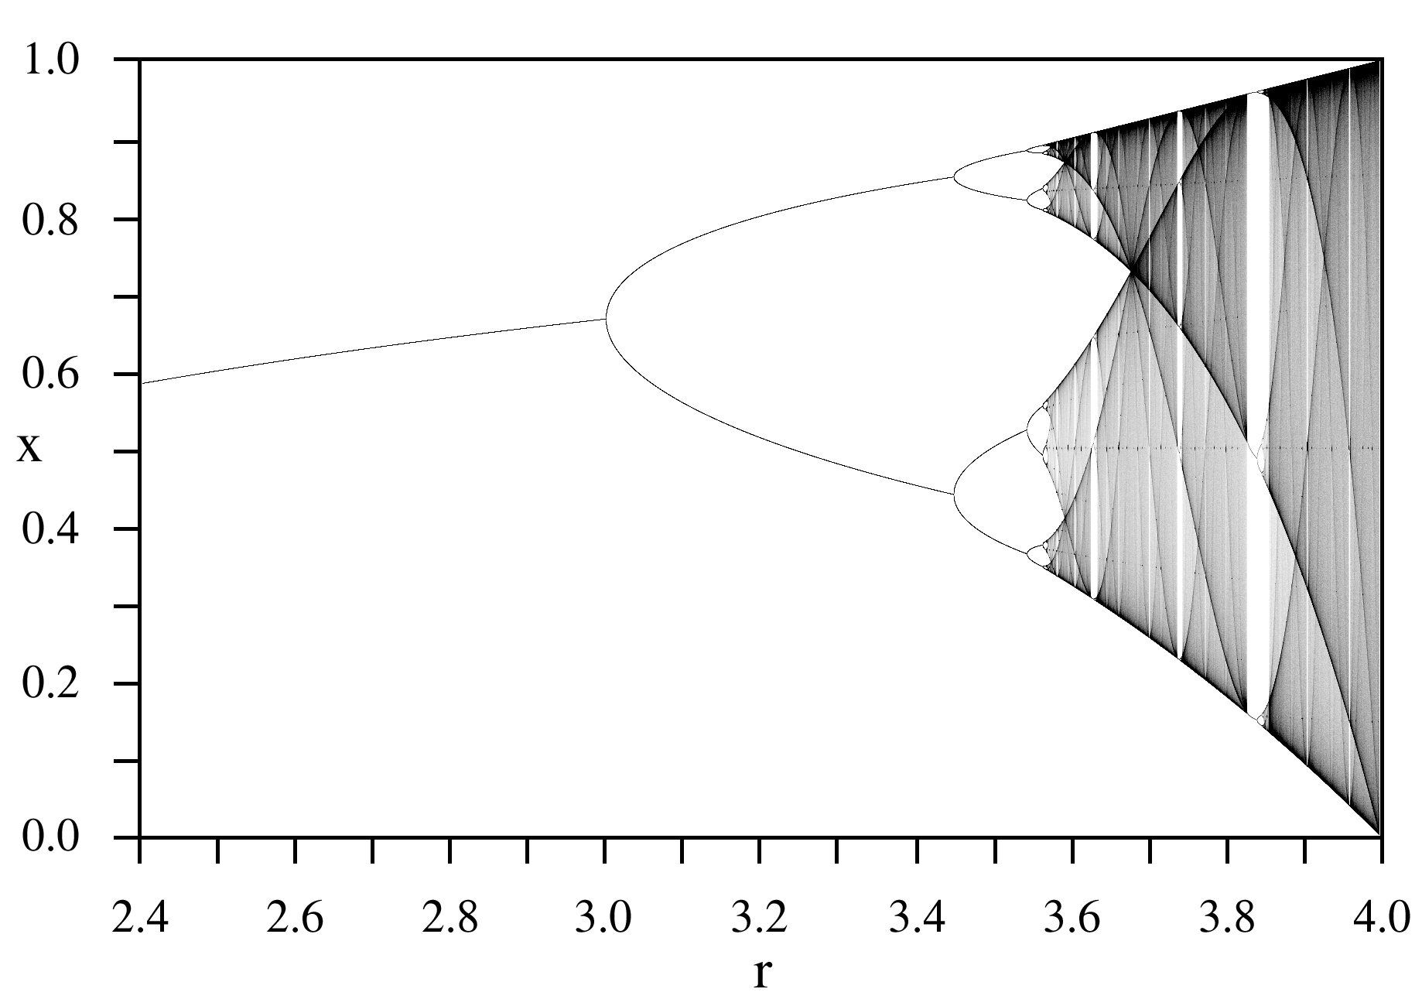

**4.3 Dynamical systems theory**

We have looked at a number of examples of complex dynamics including the double pendulum, the Lorenz equations and the Logistic Map. All of them seem to have similar types of behaviour. The mathematical theory of *dynamical systems* (see [7]) gives a way of understanding all of this. A dynamical system is simply something which *evolves in time* and is described by a state vector x(t). This can either be a function of continuous time (as in the double pendulum or the Lorenz equations), or of discrete time as in the Logistic Map. Usually a dynamical system depends on many other parameters. In such a dynamical system there will be an initial state x(0). This is then allowed to evolve. Typically the motion has a transient phase, which is dominated by the initial state, and then after a longer time patterns begin to emerge. Much of dynamical systems theory is an attempt to classify these long term evolutionary states and also to understand their stability. As the parameters in the dynamical system vary so the long term states change. A state can be created, it can disappear, it can lose its stability or it can change into a different state. We have seen all of this happen in the case of the logistic map. Typical long term behaviours include fixed points (as in the case of r < 3), periodic motions (as in the case of r = 3.2 and also for the simple pendulum), quasi-periodic motions (a combination of periodic motions, seen for example in the tides), and of course chaotic motion. The transitions between these states can be shown to take a limited number of forms, and have been studied in great detail. They are explained by ‘bifurcation theory’ (which is a development of ‘catastrophe theory’ which was very much in vogue in the 1970s.) The bifurcation diagram for the Logistic map above displays many of these features, including the celebrated ‘period-doubling route to chaos’. An excellent account of this theory is given in Drazin’s book [8].

1. **Tipping points where things change quickly**

In the introduction to this chapter I talked about the example of the straw which broke the camel’s back. What is happening in this case is that the camel (or rather its back) is the solution of a dynamical system. The parameter which controls the behaviour of this system is the amount of straw on the back of the camel. For small amounts of straw the camel’s back is a *stable* fixed point of this dynamical system. The camel is able to bear the load and it will remain in its loaded state for a long time into the future. However at a critical value of the amount of straw, the fixed point becomes *unstable.* The effect of this is that the camel’s back breaks, and the camel and straw collapse onto the ground, possibly never to rise again.

What we have seen here is a *tipping point* where a small change in the parameters governing the system leads to a *large irreversible change* in the resulting state of that system. As part of our ability to predict the behaviour of such systems we need to be able to identify whether they are close to, or maybe have even passed through, a tipping point. Electrical engineers trying to avoid a power cut due to an overloading of the power supply network, are acutely interested in such tipping points and we will look at the causes of power cuts in Chapter?? Studying tipping points is also of huge importance to our ability to predict the future climate and we will look at this topic in depth in Chapter 3 when we consider the factors leading to rapid changes in climate.

From the perspective of dynamical systems theory, the simplest model for a tipping point comes from the quadratic ordinary differential equation:



In this dynamical system x represents its state, and r is the parameter which controls the state. As always, t is time.

If **r < 0** this dynamical system has two *fixed points* at x=y and x = z where



Of these two points the lowest y is *stable*. If you start close to y then you get attracted to y at time increases. Once you get to the point y then you stay there for evermore. This behaviour is of course very predictable.

However the point z is *unstable* and if you perturb the system a little bit then it will evolve into a completely different state. If you start *below* z then the system evolves to y and if you start above z then the system goes off to infinity.

However, if the load is increased so that **r > 0** then there are *no fixed points* and x increases without bound and is *always unstable*.

We illustrate this in the following figure, where the arrows show the evolution of x with time t, and the fixed points y and z are plotted.

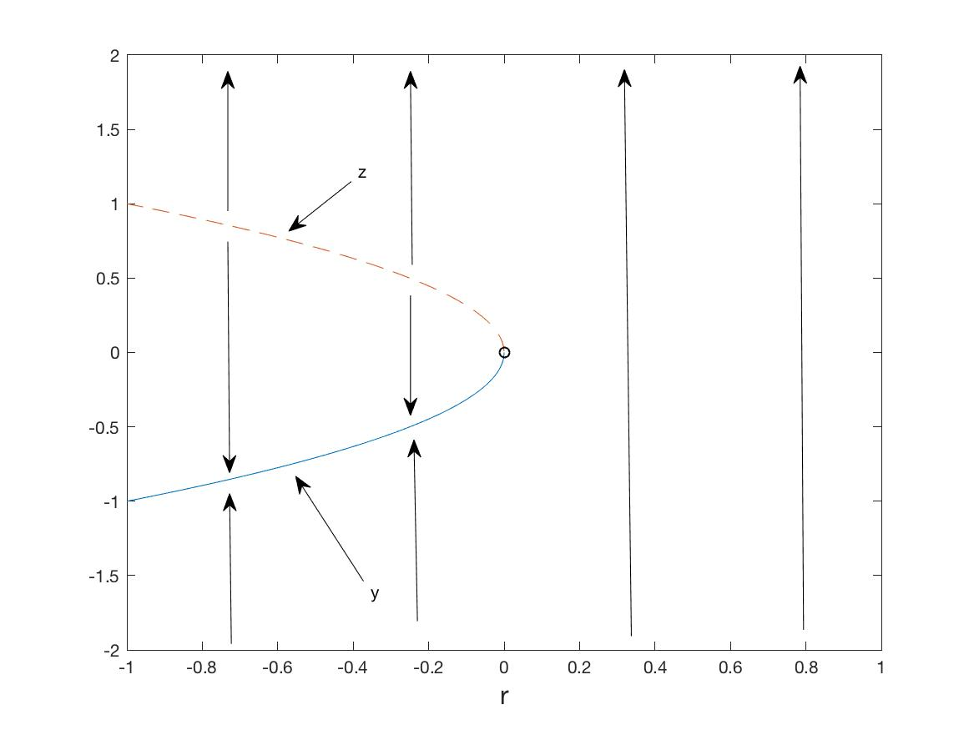

x

The point x = 0 when r = 0 is called a *tipping point.* (It also has the name of a saddle-node or a fold bifurcation). Imagine that you start at the stable fixed point y and then slowly change r from being positive to being negative. For the negative values the system stays at the slowly changing value of y. However when we hit r = 0 then everything changes and we shoot off to infinity. Everything changes at this value, hence the name tipping point (in allusion to an apple cart suddenly tipping over). Historians and economists call such behaviour a *black swan event.*

In the context of camels, the state x would represent the position of the camel’s back and r would represent the load on the camel. At a critical value of the load (corresponding to r = 0) the load is too much and the camel collapses.

I will return to the implications of this for climate change in the next Chapter. If you are interested about what happens at tipping points in a huge number of applications have a look at Gladwell’s book [9].

1. **Is chaos theory useful?**

Y0u bet it is! In many different ways. Many mathematical theories start out as being seemingly abstract and of no possible use, and then later become central to science and technology. Dynamical systems theory, including chaos theory is a very good example of this.

*Chaos theory in the real world*

Whilst Lorenz’s work in the 1960s was largely theoretical, it was quickly realised that many physical systems, such as the double pendulum, really did behave chaotically. Many other important systems are now understood to be chaotic. These include the electronic oscillators studied by Mary Cartwright, the weather (over periods of about two weeks), car exhausts, car suspensions, tubes in a boiler, power supply systems, friction brakes, climate change, solar coronal mass emissions, WiFi, EEG signals, ECG signals, and the motion of the asteroids to name just a few examples. Chaos theory allows us to understand, measure and, in some cases, control, the uncertain behaviour that such chaotic systems generally exhibit. We now appreciate that chaotic behaviour is part of the natural scheme of things for anything governed by complex, nonlinear, deterministic processes. A case in point is the asteroids. Rather than having simple orbits, many of them have highly complex orbits. It is vital that we understand this as otherwise we may not be able to predict when or if an asteroid may hit the Earth, wiping out all life in the process. Thus chaos theory is of critical importance in saving the human race!

*Fractals*

In a rather less terrifying application, chaos theory, and to be precise the theory of fractals is playing an increasingly useful role in computer graphics. We have seem in the example of the Logistic Map, how a simple rule can generate a graph with great complexity. If we apply the same process to (two-dimensional) pictures, it is possible for a simple rule acting on a two-dimensional (phase) space to generate a picture of remarkable complexity. There are hints that nature uses similar processes, and hence the patterns so produced often look very realistic. As an example here is the Barnsley Fern Fractal, which has been produced by exactly this process.



Roughly speaking a fractal is a pattern produced by a simple rule which has great complexity, so that it doesn’t matter how much you expand any part of the fractal, you will continue to see more and more detail.

Two very famous examples of fractals arising in mathematics are the Julia set and the Mandelbrot set. These are both closely linked to the logistic map that we looked at earlier, but in this case considered as a map from one *complex* number to another.

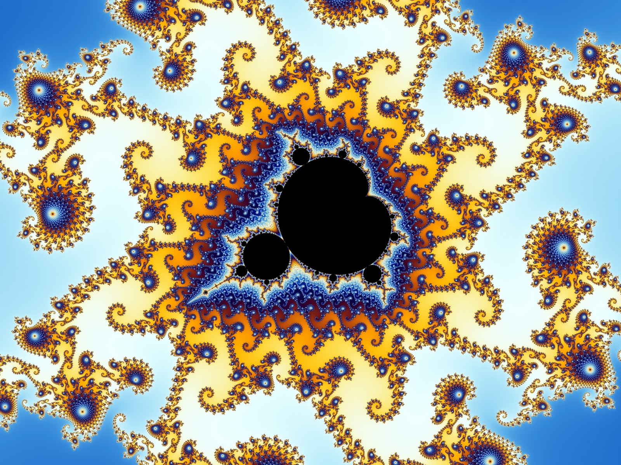

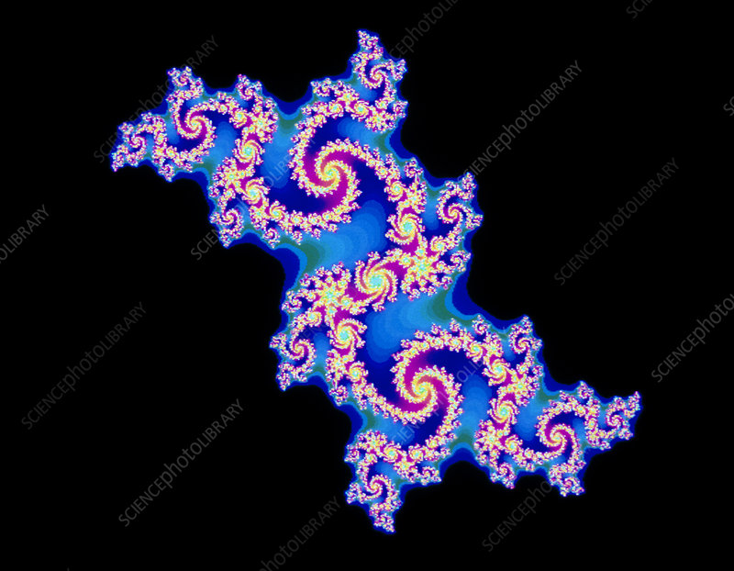

Since their discovery these fractals have been celebrated as examples of exquisite mathematical beauty and they can be found on posters and coffee cups everywhere.

Fractals also occur in nature, for example in the snowflakes that we looked at in Chapter One, in the shape of the clouds that we will look at in Chapter 3, and in the shape of coastlines, such as that of Norway (and for which Slartibartfast was given an award in the Hitchhikers Guide to the Galaxy)

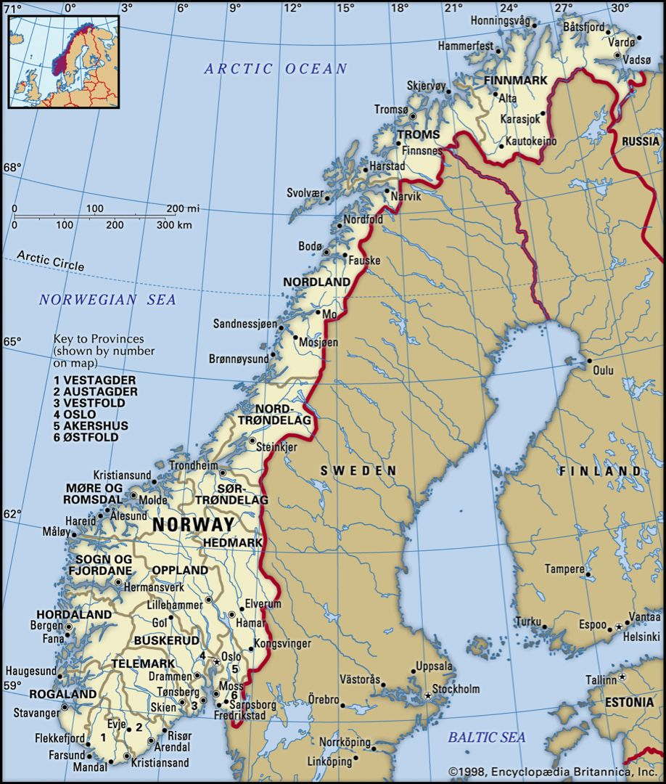

A complete account of the theory of fractals can be found in [10] and I urge you to learn more about this wonderful subject.

But perhaps the most important aspect of chaos theory is how it helps us understand how predictable the world is. We will now have a look at this.

1. **So, can we predict the future at all?**

What chaos theory tells us is that whilst some systems (those with stable fixed points or periodic orbits) can be very predictable, others are not. What we mean by that is that even given huge amounts of computing power, and an exact knowledge of the chaotic system in question, there would always be a time after which any prediction of the exact state of the system would be impossible. Laplace’s Demon is not all seeing after all.

However we can still predict many things about a system even if it is chaotic. For example I cannot tell you what the weather will be on any particular day in a future year, but I can predict that it is very likely that it will be hotter on a summers day than on a winters day.

Because all chaotic systems are described underneath by simple laws, it is often still possible to make predictions about what the system will do *on average* and often much more. (Mathematicians call such long time averages the *ergodic properties* of the system.) For studying the climate this is far more important than knowing what the weather will be on any particular day. Hence we can still predict the climate, even if we can’t predict the weather far into the future. So Laplace’s Demon still has some of the answers up their sleeve.

As an example we will return to the logistic map with r = 4, which we have shown to be chaotic. Suppose that we iterate this map 200 000 times. This will generate 200 000 iterates x(n) which will look like random numbers. If we plot a histogram of these numbers (with 40 bins) then the pattern we get has a lot of regularity.

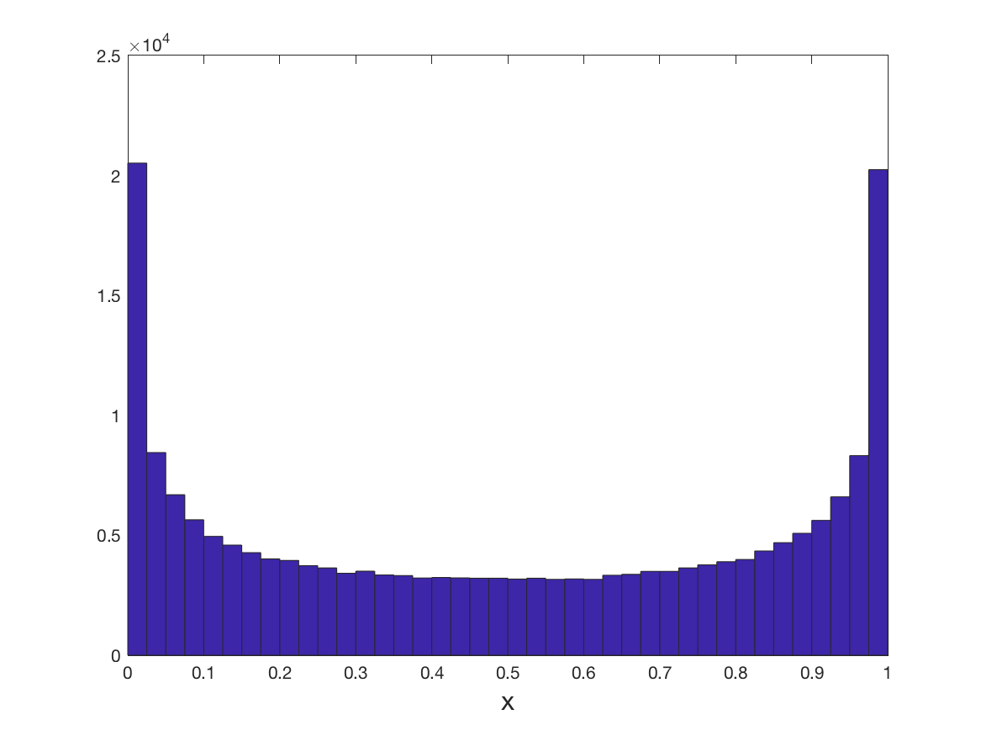

In fact with a bit of mathematical reasoning we can show that if x is chosen (randomly) from the set of the iterates then the probability P that x < y is exactly given by the expression



Using this expression we can tell a great deal about the iterates. For example they have an average of ½ and a standard deviation of 0.3536.

Similarly we will be able to deduce a lot about the ergodic properties of the climate, and we will look at this in the next Chapter.

**What next?**

It has been my privilege to work in this field most of my career. I regard chaos theory as a vital way of understanding the world with almost limitless applications. In the next Chapters we will see how this understanding helps in predicting the future of our climate, controlling our power supply, and designing new materials.

1. **References**

[1] <https://en.wikipedia.org/wiki/Laplace%27s_demon>

# [2] E Lorenz, (1963), *Deterministic nonperiodic flow*, Journal of the Atmospheric Sciences, 20, pp. 130–141

[3] *The butterfly effect*, (2004), Film

[4 ] Ray Bradbury, (1953), *The sound of thunder* in ‘The golden apples of the sun’, Doubleday.

[5] James Gleick, (1987), *Chaos: Making a new science*, Viking Press.

[6] I. Stewart, (1989), *Does God Play Dice?,* Wiley-Blackwell

[7] S. Strogatz, (1994 ), *Nonlinear dynamics and chaos*, CRC Press

[8] P. Drazin, (1992), *Nonlinear Systems*, CUP

[9] M Gladwell, (2000), *The Tipping Point,* Little, Brown and Company.

[10] K. Falconer, (2003), *Fractal Geometry*, Wiley